To update the course outlines and replace old Agribusiness lessons with new 5E lessons, follow these steps:
- Under the blue MY Courses tab
- Click on the outline
- Click on reorder lessons:
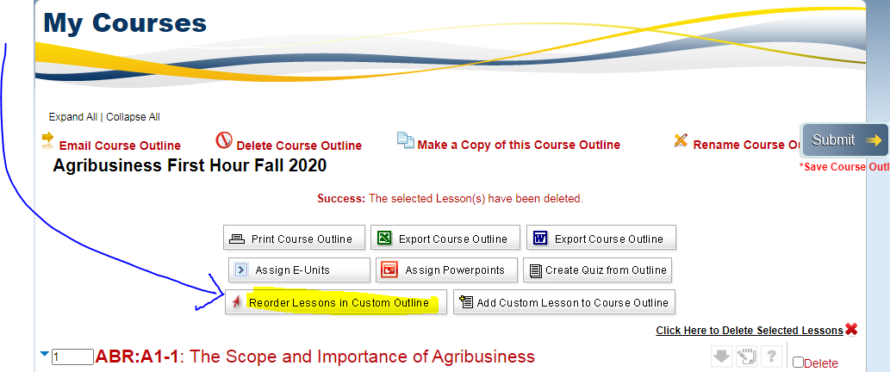

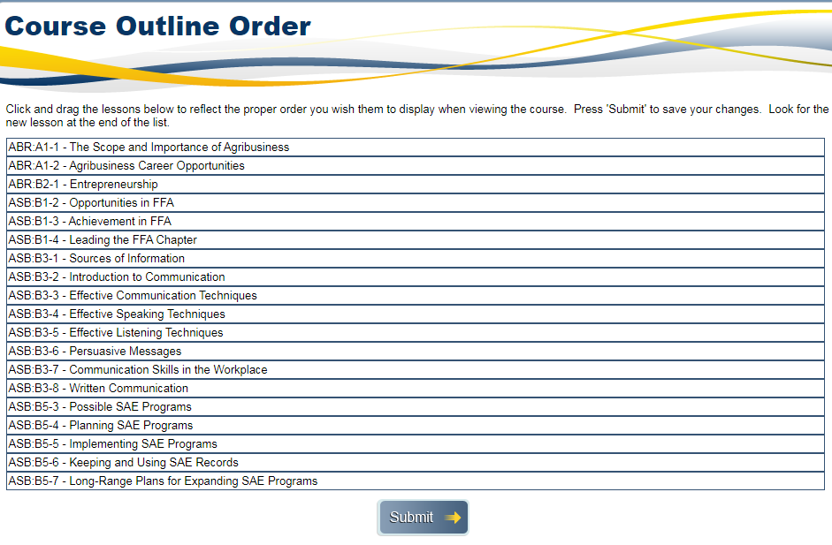

2. THIS GIVES YOU THE LESSON TITLES in a concise format to find the lessons that need to be replaced anything with ABR should be replaced with AB5E-Use the Print Screen button on your keyboard, then paste into a Word document.

3. You can perform a quick search under Generate a Course outline by vocabulary term to find your new lessons
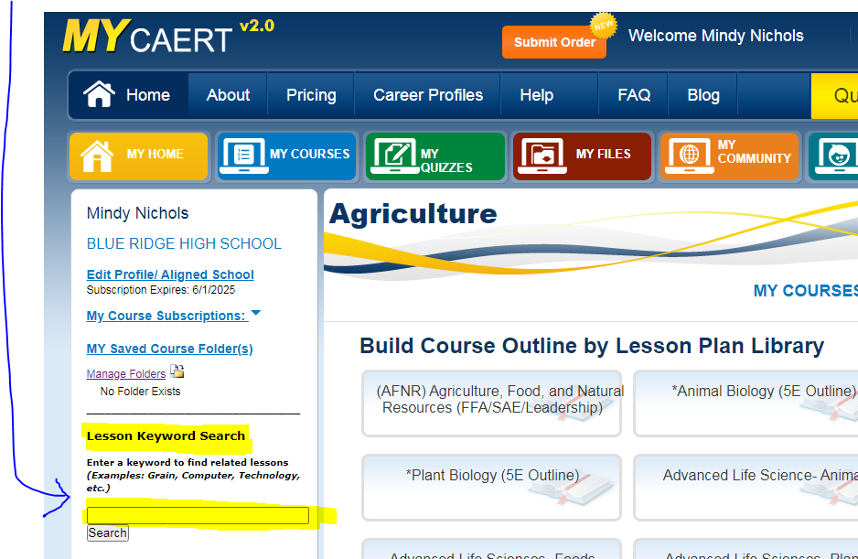
See next screenshot.

4. Or to easily see all lesson titles at once - Hover your mouse over the blue MY COURSES tab, then use the last option - by library outline: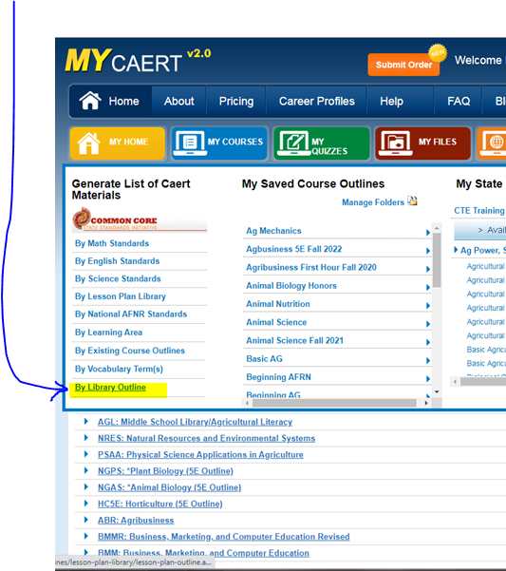

See next screenshot.

5. It will look something like this:
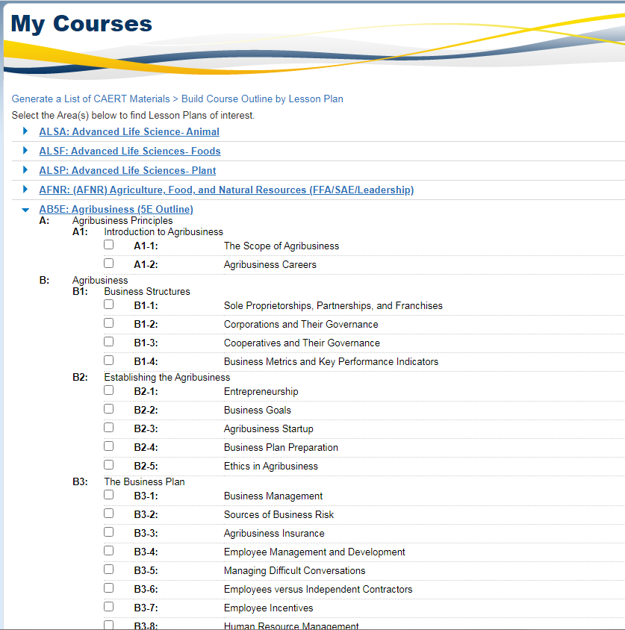

6. Mark the box next to the lesson titles that you want to use in your new outline - HIT SUBMIT. The next screen will give you a chance to name the outline.
7. Name the outline
8. Select the lessons you want to add individually, or click the red bar to ADD ALL
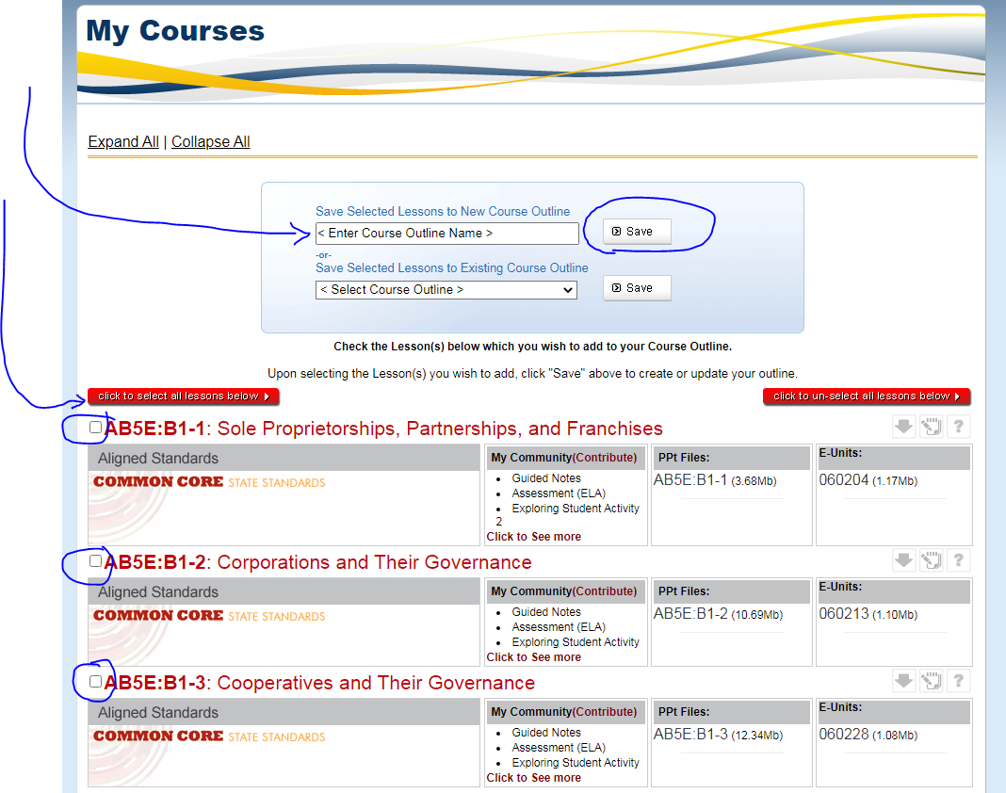

9. Your new course outline should now show up under the blue MYCOURSES tab.
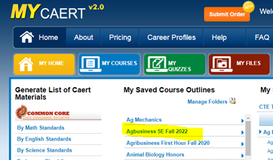

10. You are all done! If you need help, please click the gold questions tab, we are happy to help you! Or email mnichols@caert.net

